**RESUME**

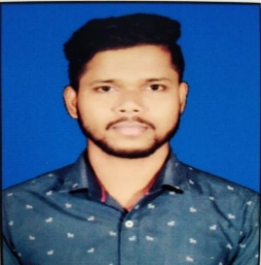

**Name: SATYA PRAKASH SAHOO**

**Email: satyaprakash.sahoo840@gmail.com**

**Contact No:** 6370788626 , 7873624740

# CAREER OBJECTIVE

I aspire to have a challenging and a rewarding position in an organization where I can put all my efforts out to an attain my personal and organizational objective processing competent technical skills.

## TECHNICAL SKILL

* **Markup:** HTML.
* **Style:** CSS, Bootstrap, SASS
* **Scripting:** JavaScript, jQuery.
* **BACKEND**: MONGODB,Nodejs,Express
* **IDE:** Visual Studio 12-19, Visual Studio Code.
* **Software efficiency:** Windows XP/7/8/10/11, Ms. Office (Word/Excel/PowerPoint).

# EXPERIENCE SUMMARY

* I have also done 6 month Training in Naresh i Technologies.
* I complete My NPETL Course Cloud Computing & Internet Of Things

## Education

* Purshing Post-Graduation from PJ Group of Institution, BBSR in Master In Computer Application

* Completed Graduation from NIIS Group of Institution, BBSR in Bachelor of Science (ITM) 2020.

### PERSONAL DETAILS

* **Name :** Satya Prakash Sahoo
* **Father’s Name :** Parikshita Sahoo
* **Mother’s Name:** Jayanti Sahoo
* **Date of Birth** : 23/01/2000
* **Marital Status** : Single
* **Nationality** : Indian
* **Language** : English, Hindi and Oriya
* **Permanent Address :** At/Po- Pankapal, Dist- Jagatsinghpur, Odisha, Pin- 754140

### DECLARATION

I hereby declare that the information given above is true and correct to the best of my knowledge and belief.

Satya Prakash Sahoo

**Signature**